Effective Casting Simulation Using
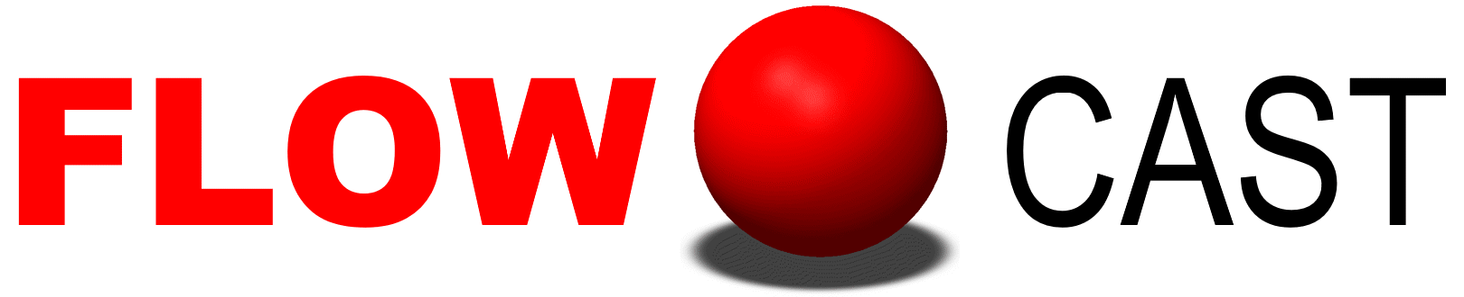
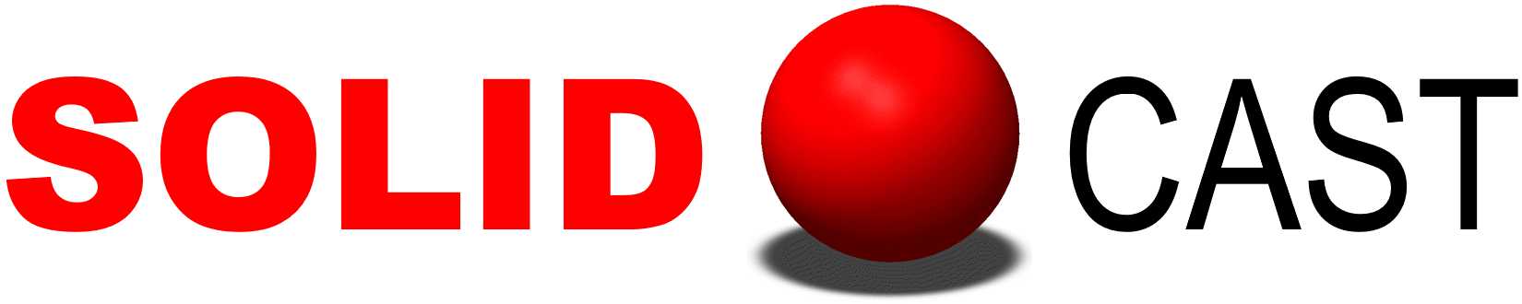
and

An On-Line Seminar Co-Hosted by
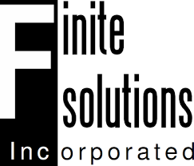

See the world’s most popular casting simulation software in action! This on-line seminar covers all aspects of system operation. Learn how to use simulation to effectively rig castings made using the Sand, Investment and Permanent Mold processes. Each attendee receives a complete set of training materials, plus a USB drive containing the latest versions of SOLIDCast and FLOWCast, case studies, papers, presentations and more! You will even get a copy of the latest Effective Casting Simulation Training Videos.

February 16-18, 2021
Training Course Schedule
(Topics and order subject to change)

Tuesday, February 16 - 9 am to 4 pm EST

Introduction and Overview of Simulation

System Installation, Activation and Setup

Sand Casting – Shrinking Alloys (Aluminum, Copper-Base, Steel, etc)

Wednesday, February 17 - 9 am to 4 pm EST
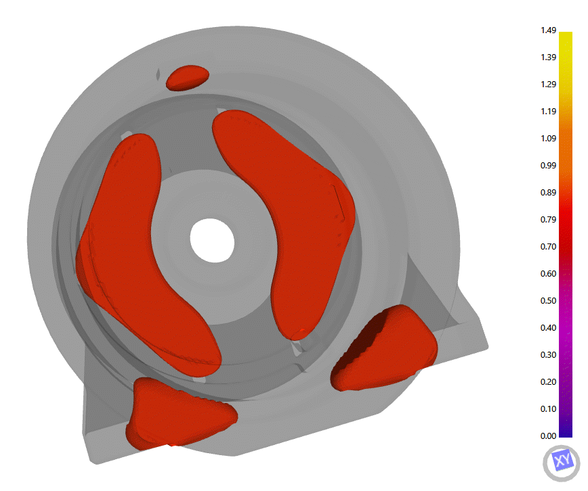
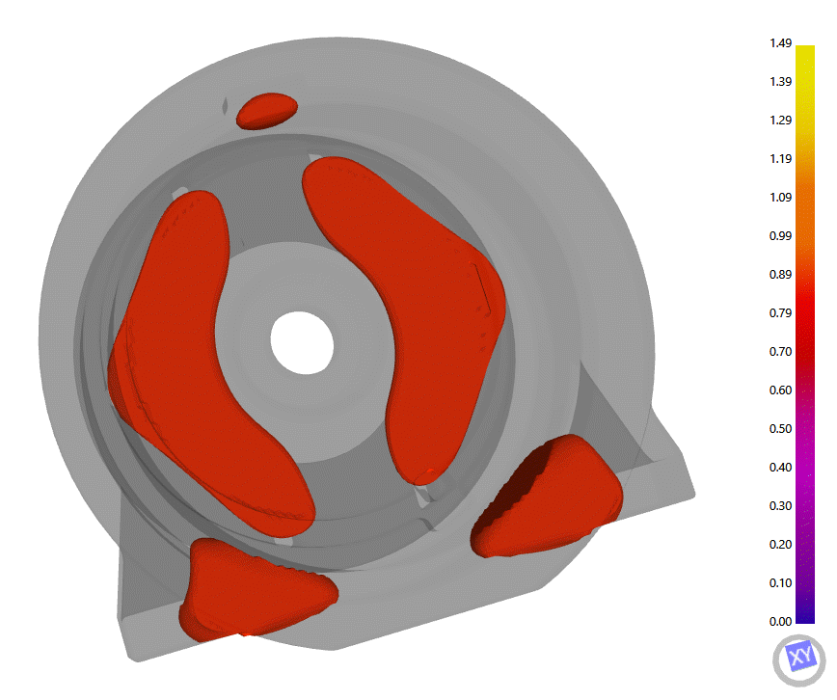
Sand Casting – Graphitic Irons

Investment Casting

Thursday, February 18 - 9 am to noon EST

Permanent Mold Casting
Plotting and Results Interpretation
Movie Making

System Utilities
For more details or to register, contact:
David Schmidt
Finite Solutions Inc
4769 Highland Park Dr
Slinger WI 53086-9441
Tel 262/644-0785 Feeding Zone Analysis for a Sand Casting
Email Dave@finitesolutions.com

SOLIDCast and FLOWCast
Effective Casting Simulation Class Registration Form

Please fill out this form and e-mail it back to Finite Solutions Inc at
dave@finitesolutions.com

Please register me for the following class session:

___ | FEB 16-18, 2021 | On-Line Seminar
Class fees are as follows: US$500 per person. If more than one person per company registers, there is a US$100/person discount. The class fee will be credited upon purchase of the software.

The first and second days of the course are conducted from 9 am to 4 pm EST. The last day is from 9 am to noon. There will be breaks at mid-morning, noon and mid-afternoon. Contact David Schmidt at Finite Solutions Inc with any questions. Email address: Dave@finitesolutions.com.

Note: When you register, we will provide you with a link to the software installation program, along with installation and activation instructions. We will make sure that the software is running properly on your machine prior to the start of class. We will also provide a 45-day evaluation license for the software.

Also note that this software requires a 64-bit version of Windows.

________________________________________________________________________________________________

Name (print) Date
________________________________________________________________________________________________

Company/School
________________________________________________________________________________________________

Address
________________________________________________________________________________________________

City State Country ZIP/Postal Code
________________________________________________________________________________________________
Telephone Email Address
________________________________________________________________________________________________

Alloy Types Poured Molding Processes Used

CREDIT CARD (Visa, MasterCard, American Express)________________________________________EXP___________

SIGNATURE _____________________________________ PRINT NAME ______________________________________

OR CHECK ENCLOSED _________ WILL BE MAILED _________

NOTE: PAYMENT IS REQUIRED TO SECURE YOUR RESERVATION IN THIS COURSE. PLEASE MAKE CHECKS PAYABLE TO FINITE SOLUTIONS INC. MAIL ALL CHECKS TO:

Finite Solutions Inc.

2931 Hamilton New London Rd

Hamilton, OH 45013

